|  |  |
| --- | --- |
| **Ex. No. 5** | **JAVASCRIPT – DOM ELEMENTS AND EVENTS** |
| **Date of Exercise** | 09.08.2023 |

**Aim**

To create a javascript DOM elements and events using javascript.

**Description**

* A Document object represents the HTML document that is displayed in that window.
* Document object has various properties that refer to other objects which allow access to and modification of document content.
* The way a document content is accessed and modified is called the Document Object Model, or DOM.
* var myElement = document.getElementById("intro");
* The JavaScript syntax defines two types of values Fixed values are called Literals, Variable values are called Variables.
* In a programming language, **variables** are used to **store** data values, JavaScript uses the keywords var, let and const to **declare** variables.
* An **equal sign** is used to **assign values** to variables, All JavaScript **variables** must be **identified** with **unique names**.
* These unique names are called **identifiers**. A JavaScript function is defined with the function keyword, followed by a **name**, followed by parentheses **()**.
* Function names can contain letters, digits, underscores, and dollar signs (same rules as variables). When JavaScript reaches a return statement, the function will stop executing.
* If the function was invoked from a statement, JavaScript will "return" to execute the code after the invoking statement. Functions often compute a **return value**.
* JavaScript functions are used to perform operations. We can call Javascript function many times to reuse the code. In JavaScript the purpose of function constructor is to create a new function object.

**Program**

1. **Design a webpage using HTML, CSS and JavasScript as per the following design and perform the Cake order calculation using JavaScript. [use onclick event]**

<!DOCTYPE html>

<html lang="en">

<head>

<meta charset="UTF-8">

<meta name="viewport" content="width=device-width, initial-scale=1.0">

<title>Cake Order</title>

<style>

body {

font-family: Arial, sans-serif;

}

#cake-options {

display: flex;

flex-direction: column;

gap: 10px;

margin-bottom: 20px;

}

.cake-option {

display: flex;

align-items: center;

gap: 10px;

}

.grid-container {

display: grid;

grid-template-columns: repeat(auto-fit, minmax(200px, 1fr));

gap: 20px;

}

.item {

text-align: center;

}

.item img {

max-width: 100%;

height: auto;

}

.center-content {

display: flex;

justify-content: center;

align-items: center;

}

</style>

</head>

<body>

<div style="background-color: red;text-align: center;">

<h1>Cake shop</h1>

</div>

<div class="grid-container">

<div class="item">

<img src="OIP.jpeg"><br>

<label>Brown Cake-Rs. 200</label>

</div>

<div class="item">

<img src="OPA.jpeg"><br>

<label>Milk Cake-Rs. 250</label>

</div>

<div class="item">

<img src="https://th.bing.com/th/id/OIP.L94yAbZa4nPhKHgdIDZlwwHaHa?w=198&h=198&c=7&r=0&o=5&dpr=1.5&pid=1.7">

<br><label>Black Forest Cake-Rs. 350</label>

</div>

<div class="item">

<img src="download.jpeg"><br>

<label>Color Cake-Rs. 300</label>

</div>

</div>

<div class="center-content">

<h1>Order Cake</h1></div>

<div class="center-content">

<div id="cake-options">

<div class="cake-option">

<label for="chocolate">Color Cake - Rs 300</label>

<input type="number" id="chocolate" min="0" value="0" onchange="calculateTotal()">

</div>

<div class="cake-option">

<label for="vanilla">Milk Cake - Rs 250</label>

<input type="number" id="vanilla" min="0" value="0" onchange="calculateTotal()">

</div>

<div class="cake-option">

<label for="strawberry">Black Forest Cake - Rs 350</label>

<input type="number" id="strawberry" min="0" value="0" onchange="calculateTotal()">

</div>

<div class="cake-option">

<label for="lemon">Brown Cake - Rs 200</label>

<input type="number" id="lemon" min="0" value="0" onchange="calculateTotal()">

</div>

</div>

</div>

<p style="text-align: center;">Total Cost: $<span id="total">0</span></p>

<script>

function calculateTotal() {

const chocolateQuantity = parseInt(document.getElementById('chocolate').value);

const vanillaQuantity = parseInt(document.getElementById('vanilla').value);

const strawberryQuantity = parseInt(document.getElementById('strawberry').value);

const lemonQuantity = parseInt(document.getElementById('lemon').value);

const chocolatePrice = 300;

const vanillaPrice = 200;

const strawberryPrice = 350;

const lemonPrice = 200;

const totalCost = (chocolateQuantity * chocolatePrice) +

(vanillaQuantity * vanillaPrice) +

(strawberryQuantity * strawberryPrice) +

(lemonQuantity * lemonPrice);

document.getElementById('total').textContent = totalCost;

}

</script>

</body>

</html>

1. **Create a web application to develop the following Bank loan EMI calculator using client side Java Script. The formula for calculating the EMI is given below. Where, P is Loan Amount, R is a rate of interest and N is a tenure in months. [convert Year as months] [Use onkeyup event]**

<!DOCTYPE html>

<html>

<head>

<title>Bank Loan EMI Calculator</title>

<style>

body {

display: flex;

justify-content: center;

align-items: center;

height: 100vh;

margin: 0;

background-color: #f0f0f0;

}

.calculator {

text-align: left;

padding: 20px;

border-radius: 10px;

background-color: #fff;

box-shadow: 0 0 10px rgba(0, 0, 0, 0.2);

width: 300px;

}

label {

display: block;

margin-top: 10px;

}

.result-heading {

background-color: #3498db;

color: #fff;

padding: 10px;

border-radius: 5px;

margin-top: 10px;

font-weight: bold;

}

.result-bar {

background-color: #e0e0e0;

padding: 10px;

border-radius: 5px;

margin-top: 5px;

font-weight: bold;

}

</style>

<script>

function formatCurrency(amount) {

return '₹' + amount.toFixed(2);

}

function calculateEMI() {

var loanAmount = parseFloat(document.getElementById("loanAmountInput").value);

var annualInterestRate = parseFloat(document.getElementById("annualInterestRate").value) / 100;

var monthlyInterestRate = annualInterestRate / 12;

var tenureInYears = parseFloat(document.getElementById("tenureInYears").value);

var tenureInMonths = tenureInYears * 12;

var emi = (loanAmount * monthlyInterestRate * Math.pow(1 + monthlyInterestRate, tenureInMonths)) / (Math.pow(1 + monthlyInterestRate, tenureInMonths) - 1);

var totalRepayment = emi * tenureInMonths;

var totalInterest = totalRepayment - loanAmount;

document.getElementById("loanAmount").innerHTML = formatCurrency(loanAmount);

document.getElementById("emiResult").innerHTML = formatCurrency(emi);

document.getElementById("totalRepaymentResult").innerHTML = formatCurrency(totalRepayment);

document.getElementById("totalInterestResult").innerHTML = formatCurrency(totalInterest);

}

</script>

</head>

<body>

<div class="calculator">

<h1>Bank Loan EMI Calculator</h1>

<label for="loanAmountInput">Loan Amount:</label>

<input type="number" id="loanAmountInput" placeholder="Loan Amount" onkeyup="calculateEMI()">

<label for="annualInterestRate">Annual Interest Rate (%):</label>

<input type="number" id="annualInterestRate" placeholder="Annual Interest Rate" onkeyup="calculateEMI()">

<label for="tenureInYears">Tenure in Years:</label>

<input type="number" id="tenureInYears" placeholder="Tenure in Years" onkeyup="calculateEMI()">

<div class="result-heading">Loan Amount</div>

<div class="result-bar" id="loanAmount"></div>

<div class="result-heading">EMI</div>

<div class="result-bar" id="emiResult"></div>

<div class="result-heading">Total Repayment</div>

<div class="result-bar" id="totalRepaymentResult"></div>

<div class="result-heading">Total Interest</div>

<div class="result-bar" id="totalInterestResult"></div>

</div>

</body>

</html>

**Output**

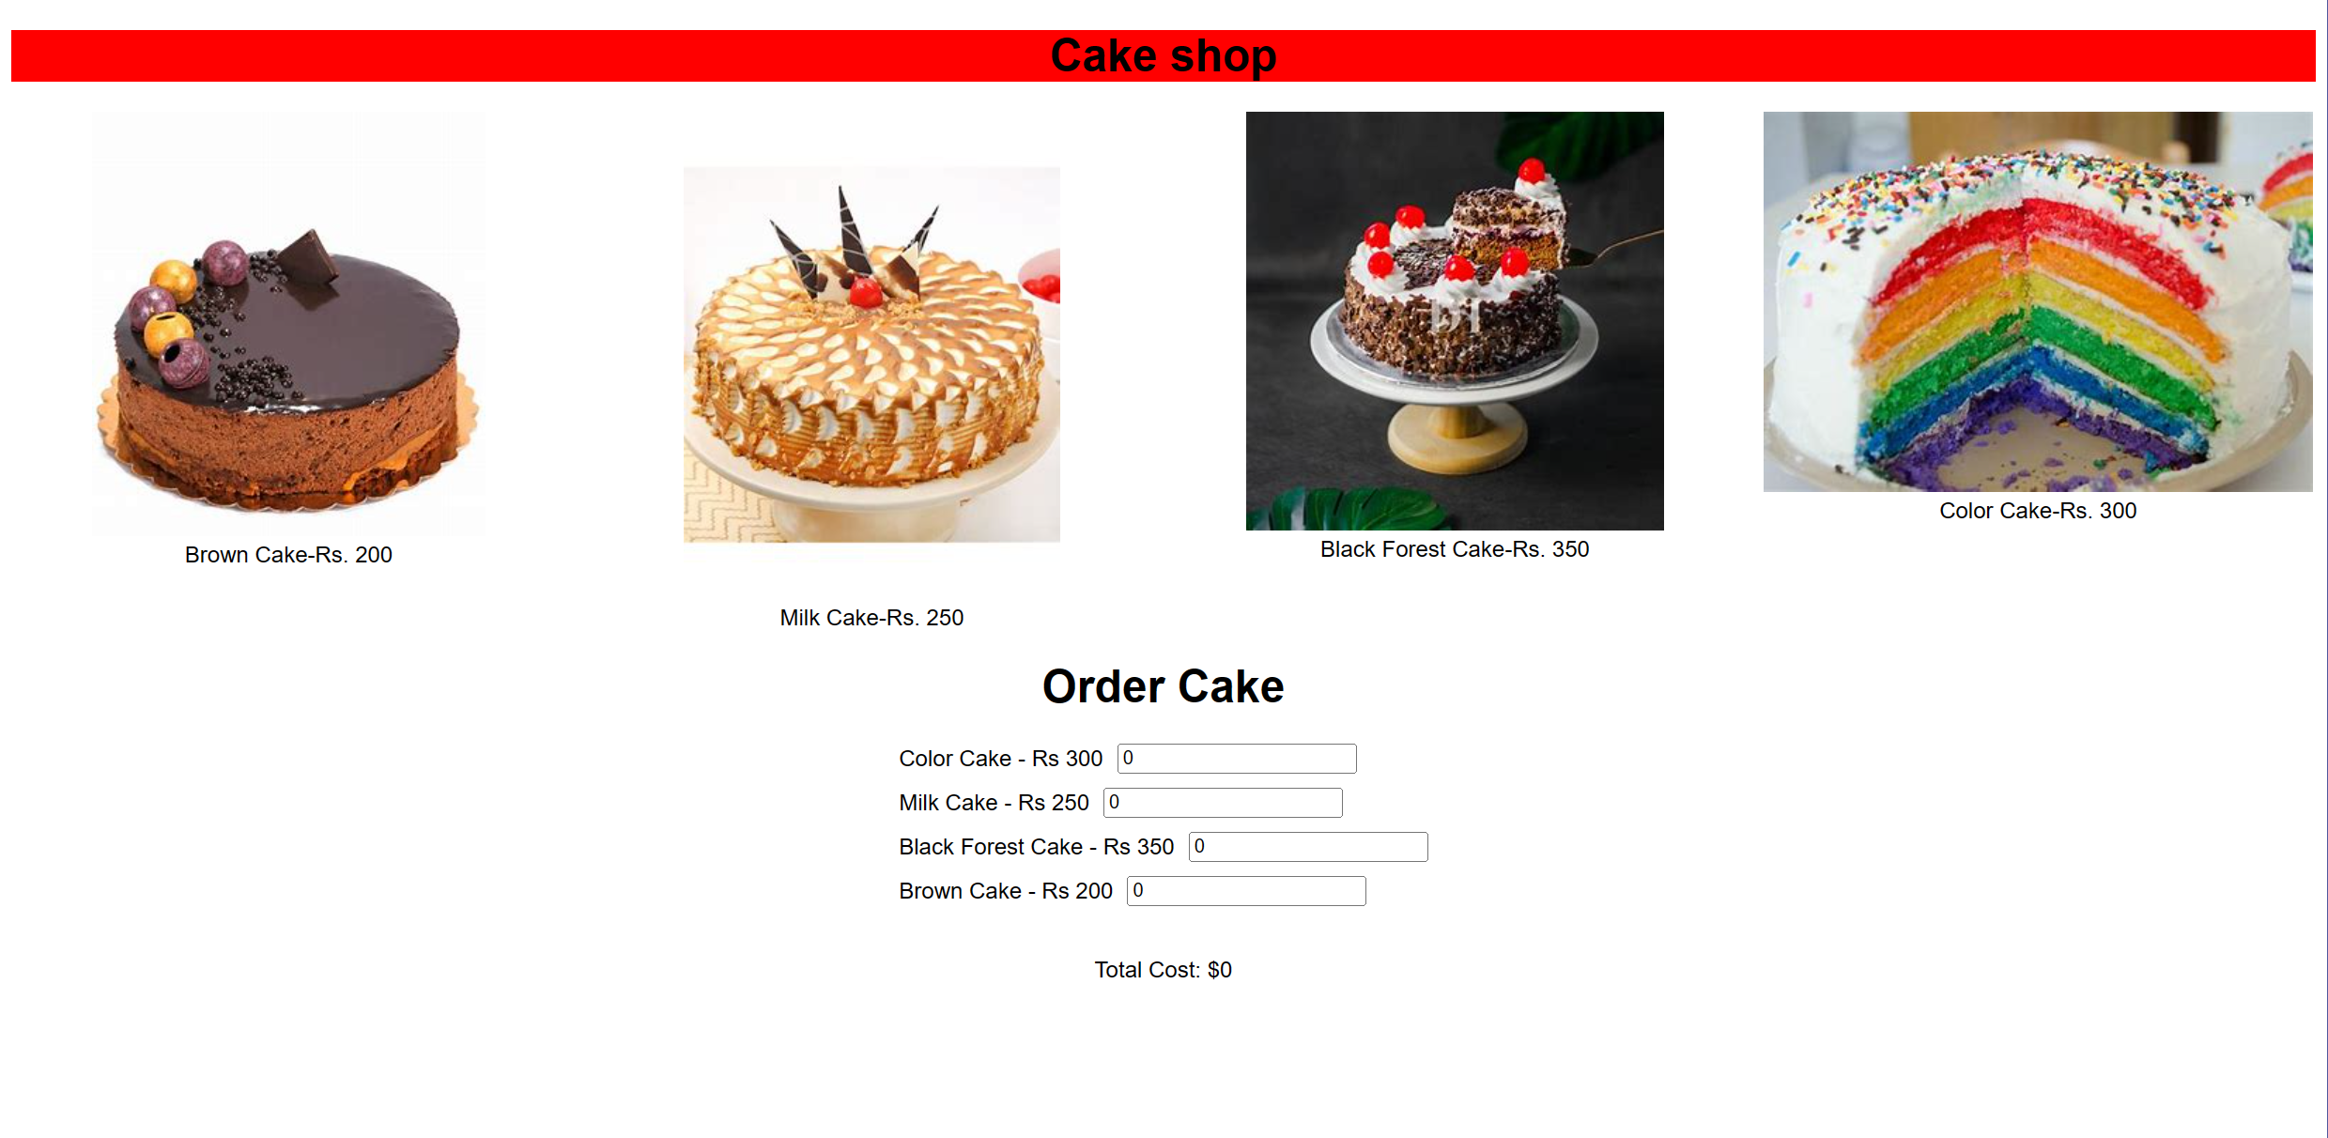

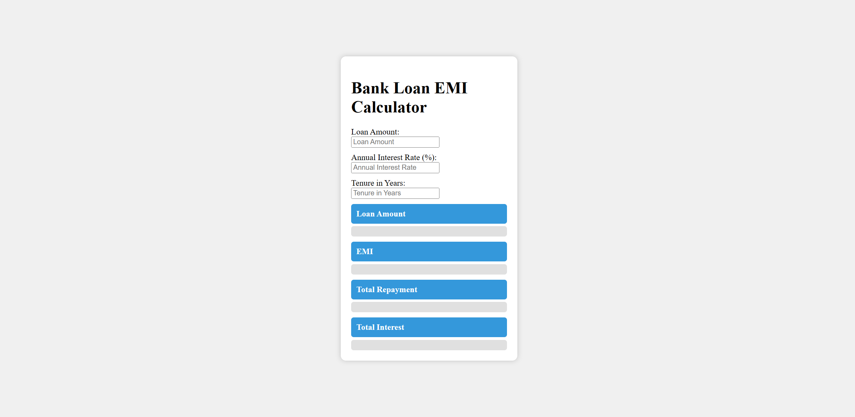

**Result**

The program is executed successfully and the program output is displayed in the web browser.